Lecture 3
Arrays are objects in Java. So assigning one array variable to another will just make them refer to the same object:
import java.util.Arrays;

public class test {
public static void main(String args[]){
int [] a = {1, 2, 3};
int [] b = {4, 5, 6};
a = b;
a[0] = 7;
System.out.println(Arrays.toString(a)); // Output: [7, 5, 6]
System.out.println(Arrays.toString(b)); // Output: [7, 5, 6] because a and b reference the same array
}
}

Multidimensional Arrays
Two-dimensional arrays:
type mArray[][] = new type[size1][size2];
or
type mArray[][];
mArray = new type[][]{ { x11, x12 ,…, x1m }, … , { xn1, xn2 ,…, xnm }}
Three-dimensional arrays:
type mArray[][][] = new type[size1][size2][size3];
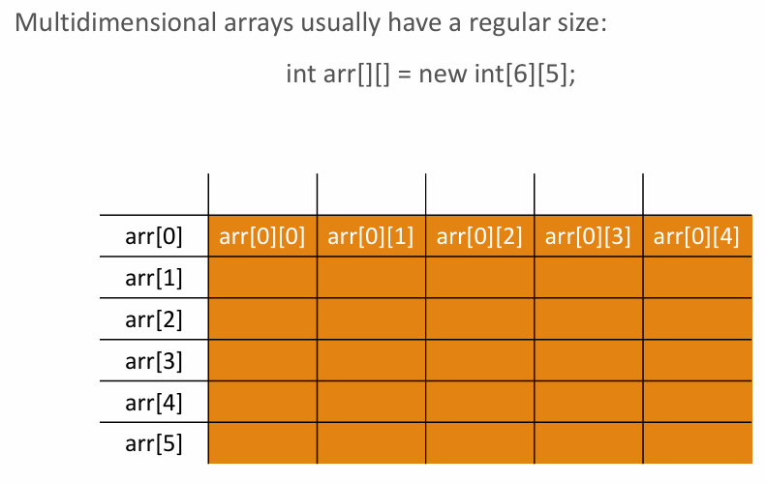
So first is row, second one is column size
Irregular arrays=jagged arrays
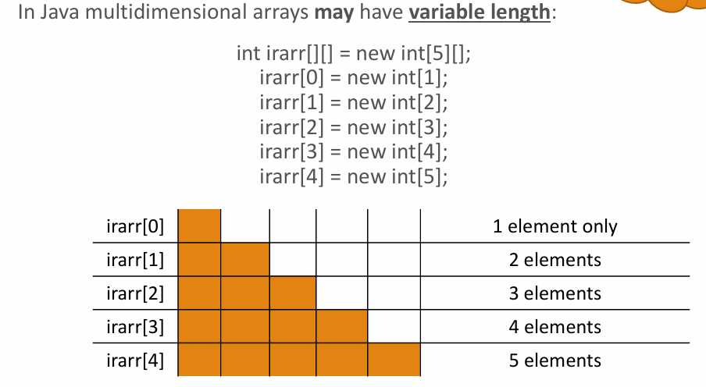

An array object has an automatically assigned length variable -> a.length
Length of multidimensional array
public class test {
public static void main(String args[]){
int a[][] = { {1, 2}, {3, 4}, {5, 6} };
System.out.println("The size of array is : (" + a.length + ", " + a[0].length+")"); // The size of array is : (3, 2)
}
}
In multidimentional case, arr.length gives the size of first dimension, arr[x].length gives the size of the arr[x] element and so on.
Receiving and returning an array
int [] getArray() {
int [] arr = {1, 2, 3, 4, 5};
return arr;
}
void changeArray(int [] arr) {
}

For-each (enhanced for) loop
Syntax:
for (type iterationVar : array) {
statement;
}
public class test {
public static void main(String args[]){
int [] arr = { 2, 4, 55, -4, 3};
int sum = 0;
for (int x : arr) {
sum += x;
}
System.out.println("sum: " + sum);
}
}

Syntax for multidimensional array:
for (type iterationVar [] : mdArray) {
statement;
}
public class test {
public static void main(String args[]){
int [][] arr = { {1, 2, 3, 4, 5}, {6, 7, 8, 9, 10}, {11, 12, 13, 14, 15} };
int sum = 0;
for (int x[] : arr) {
for (int y : x) {
sum += y;
}
}
System.out.println("sum: " + sum);
}
}

Foreach is read-only.

Java data types
- primitive data types (int, char, double)
- non-primitive data types – a.k.a. reference DT – “Array”, String, Integer, BigDecimal..
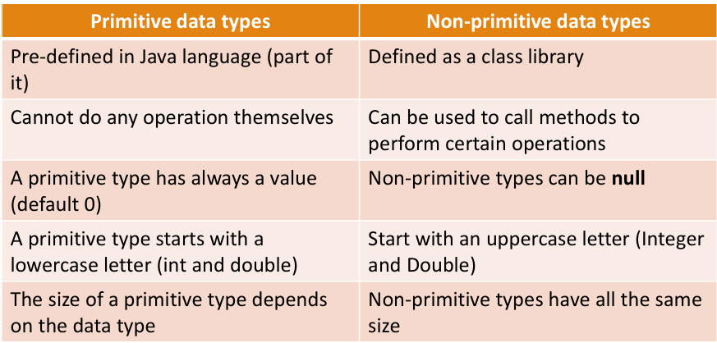
Non-primitive variables do NOT store the object itself. They store a reference (address) pointing to the object in memory. the reference (pointer) is usually the same size. which is typically:
- 4 bytes (32-bit JVM)
or
- 8 bytes (64-bit JVM)
So the variable size is the same, because they only store addresses, not the real data.

String -> in Java String is an object, not an array of characters.
public class test {
public static void main(String args[]){
// Easy way
String str = "Hello all";
String str3 = str; // reference to the same string object
str3 = "Hello everyone"; // str3 now references a new string object, str still references "Hello all"
System.out.println(str); // output: Hello all
// with string constructor
String str2 = new String("Hello all");
// copy of another string (not reference to it!)
String newStr = new String(str);
}
}
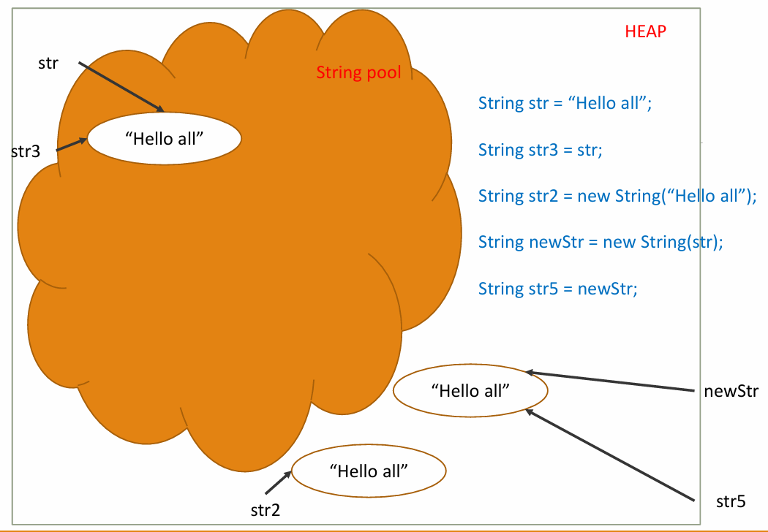
String methods
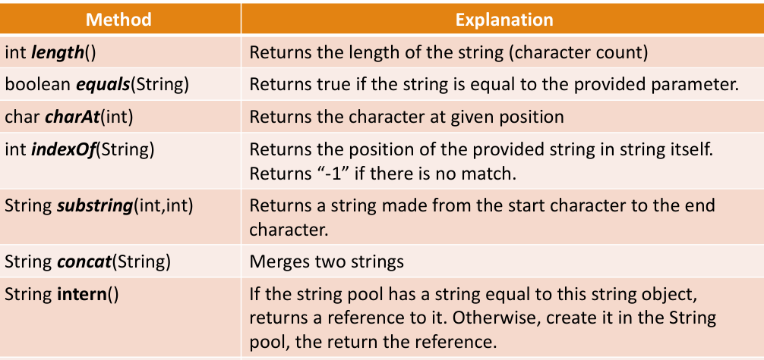
public class test {
public static void main(String args[]){
String a = "Hello";
String b = a.concat(" World");

System.out.println(b); // Output: Hello World
}
}
Substring:
start index → INCLUDED
end index → EXCLUDED
public class test {
public static void main(String args[]){
String s = "Hello";

System.out.println(s.substring(1,4)); // prints "ell"
}
}
Intern:
public class test {
public static void main(String args[]){
String a = new String("Hello"); // forces a new object to be created outside of the string pool in heap memory
String b = a.intern(); // returns the reference from the string pool
// The intern() method checks if the string "Hello" is already in the string pool. If it is, it returns the reference to that string. If it is not, it adds the string to the pool and then returns the reference.
// So b points to the pooled string.
String c = "Hello";

System.out.println(b == c); // true, because both b and c point to the same string in the pool
System.out.println(a == b); // false, because a points to the string object in heap memory, while b points to the string in the pool
}
}

Strings are immutable .
public class test {
public static void main(String args[]){
String str = "Some text";
String newStr = str.toLowerCase(); // str itself is not changed, the result of
// operation is returned as a new value
}
}

?: (ternary) operator = short-if -> used to replace the general if-else statements
Syntax:
booleanRule ? OperationIfTrue : OperationIfFalse;
Does the same as:
if (booleanRule)
OperationIfTrue;
else
OperationIfFalse;

Wrapper classes – int - Integer
Advantages:
◦ Call by reference
◦ Some classes/methods use only reference data types instead of primitive.
◦ Data serialization and synchronization
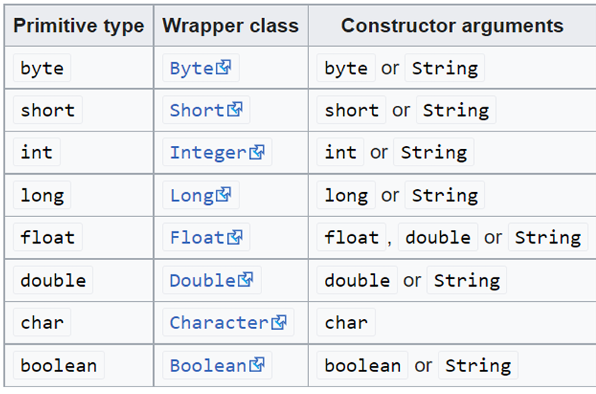

Autoboxing
Automatic conversion of a primitive data type to an object of the corresponding reference data type (Wrapper class) is called autoboxing.
class C{
void f(Integer num){
System.out.println(num);
}
public static void main(String[] args){
new C().f(125);
}
//although 125 is of type int
//it automatically is converted into Integer
}

Unboxing
Automatic conversion of an object of a reference data type (Wrapper class) to the corresponding primitive data type to is called unboxing. (opposite of autoboxing).
class C{
void f(float num){
System.out.println(num);
}
public static void main(String[] args){
Float x = 3.14f;
new C().f(x);
//although 3.14 is of type Float
//it automatically is converted into float
}
}

